Ocean Vocabulary
(Create a Frayer Model for each Vocabulary Term-see example on back)

Salt Water/Oceans:
Aphotic Zone: the portion of a lake or ocean where there is little or no sunlight;formally defined as the depths beyond which less than 1% of sunlight penetrates.
Benthic Zone: the ecological region at the lowest level of a body of water such as an ocean or a lake, including the sediment surface and some sub-surface layers
Downwelling: the downward movement of fluid, especially in the sea, the atmosphere, or deep in the earth
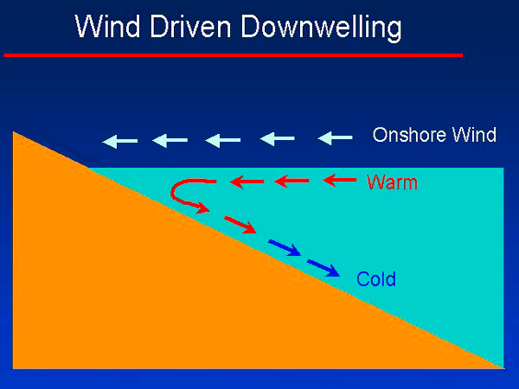
Estuary: a place where freshwater meets up with salt water; nature’s nursery
Hydrothermal vents: a fissure in a planet's surface from which geothermally heated water issues. Hydrothermal vents are commonly found near volcanically active places, areas where tectonic plates are moving apart, ocean basins, and hotspots.
Intertidal Zone: the area of the shore and seabed that is exposed to the air at low tide and submerged at high tide, i.e. the area between tide marks
Neritic Zone: the relatively shallow part of the ocean above the drop-off of the continental shelf, approximately 200 meters in depth
Open Ocean: the sunlit top layer of the ocean beyond the continental shelves; the vast bulk of the sea, it covers over 360,000,000 square kilometers of the Earth's surface and is referred to as the 'marine desert' because nutrients are lower here than in the shallow seas; life can be scarce
Photic Zone: surface layer of the ocean that receives sunlight
Phytoplankton: microscopic marine producers/base of an aquatic food web
Stewardship: taking care of something
Upwelling: wind-driven process in which nutrient-rich, denser, colder water moves to the surface

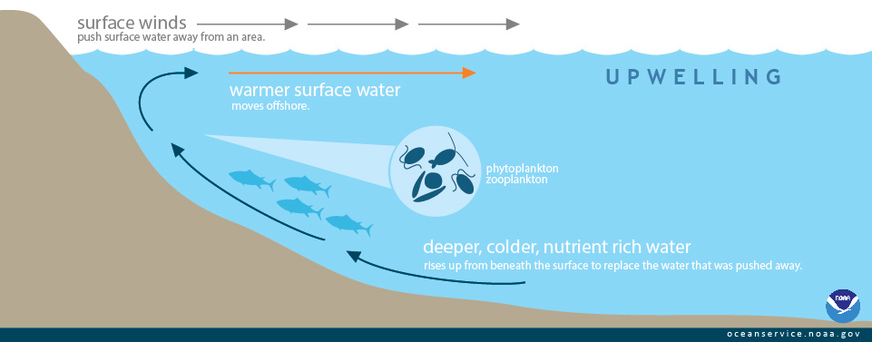

Example of a Frayer Model

Vocabulary Word:_________________________

Definition: | Examples:
Write a sentence with the word in context: | Picture:

