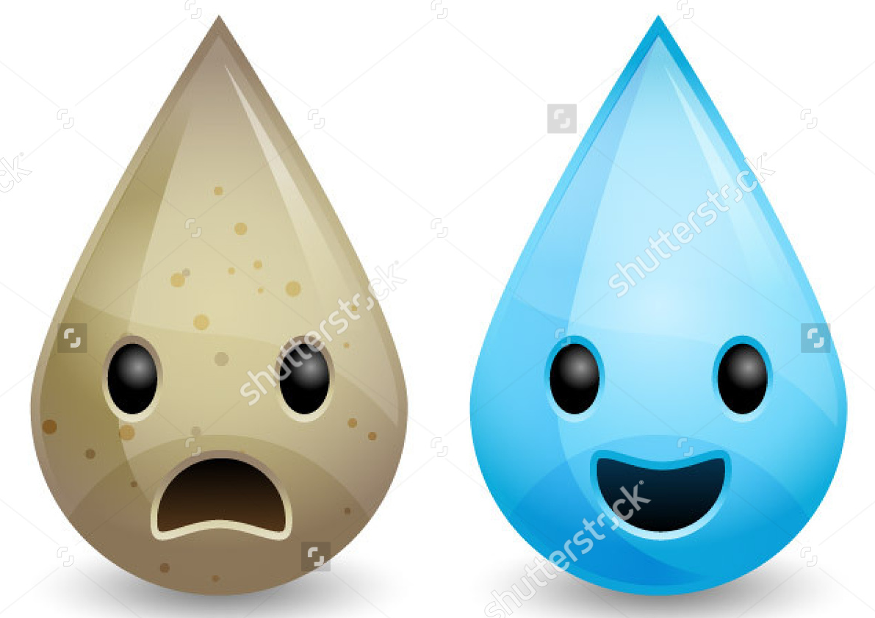 WATER QUALITY RESEARCH
Using the web sites provided, gather & record the following information. Be thorough when collecting information.

BACKGROUND RESEARCH

- As a class, how would you define water quality?

INDICATORS | DEFINITION | HOW DO THEY AFFECT WATER QUALITY?
1.
2.
3.
4.
5.
6.
7.

- What is eutrophication?

- What is the chain reaction that can occur in a body of water that has eutrophication?

 | DEFINITION | EXAMPLES
Point Source Pollution
Non Point Pollution

- Who mandates the water quality standards?

- What was the first law passed for U.S. water quality standards?
  - When was it passed?
  - What does it state?

WATER TREATMENT RESEARCH

WATER TREATMENT STEPS | DESCRIPTION
1
2
3
4
5

Using the following link choose the 4 most surprising statistics in relation to water pollution.
In three to four sentences explain why you found each statistic to be shocking.
http://www.conserve-energy-future.com/various-water-pollution-facts.php

- There are countless inventions for new ways to purify water. Narrow it down to your top 4 and describe how they are a potential solution to poor water quality.

ALTERNATIVE TREATMENT METHODS | HOW DO THEY WORK?
1
2
3
4

Global Water Crisis (click on this link https://tinyurl.com/y9mv8ue9)
GLOBAL/LOCAL CRISIS LOCATION =
When did the crisis start?
What is the main cause of the crisis?

Would it be considered point source, or nonpoint source pollution?

What are the current water quality statistics for the area? (pH, turbidity, nitrates, etc.)

Who is specifically impacted by the current crisis? (businesses, industry, agriculture, residential areas, etc.)

How many total people have been affected?

Have there been any previously attempted solutions?
If not, why not. If so, then what happened? Why didn’t it end the crisis?

What is your suggested plan for solving the crisis? (can be a bulleted/numbered list)
WATER QUALITY LINKS
Intro
https://drive.google.com/file/d/0B3pcTykhVmgMdjRnd29YaHY5MUU/view
http://floridakeys.noaa.gov/ocean/waterquality.html
https://drive.google.com/open?id=1-ZvwGQgxKjfyjFaNsLQMY31KyvEVWxvH

Indicators
http://sciencelearn.org.nz/Contexts/Enviro-imprints/Science-Ideas-and-Concepts/Bioindicators
https://water.usgs.gov/edu/dissolvedoxygen.html
https://water.usgs.gov/edu/nitrogen.html
http://www.freedrinkingwater.com/water_quality/quality1/1-what-nitrate-and-phosphate-do.htm
https://water.usgs.gov/edu/phosphorus.html
https://water.usgs.gov/edu/ph.html
https://water.usgs.gov/edu/temperature.html
https://water.usgs.gov/edu/turbidity.html

http://www.water-pollution.org.uk/eutrophication.html
http://oceanservice.noaa.gov/education/kits/estuaries/media/supp_estuar09b_eutro.html

Point vs Non-Point
https://www.epa.gov/nps/what-nonpoint-source
http://www.pollutionissues.com/Pl-Re/Point-Source.html
http://extension.usu.edu/waterquality/whats-in-your-water/pollution/

Regulations
https://www.epa.gov/standards-water-body-health/how-are-water-quality-standards-developed
https://www.epa.gov/wqs-tech
http://www.nwf.org/What-We-Do/Protect-Habitat/Waters/Clean-Water-Act.aspx

WATER TREATMENT LINKS
Treatment
http://www.livestrong.com/article/128483-steps-water-purification/
https://durhamnc.gov/1196/Water-Treatment-Process

Alternatives
http://mashable.com/2015/03/22/world-water-day-inventions/#UsOja1zphmqP
http://www.goodnet.org/articles/5-amazing-inventions-that-deliver-clean-water-videos
http://www.enviroalternatives.com/watermethods.html

